ADAPTIVE MULTI-CELL BATTERY
INTELLIGENCE ENGINE
ESP32-Based Multi-Cell Voltage Monitoring & Diagnostics System
PROJECT REPORT
Platform: ESP32 Development Board
Sensors: 4 x Potentiometer (Cell Voltage Simulation)
Date: July 2026

1. Introduction
This project implements an Adaptive Multi-Cell Battery Intelligence Engine using an ESP32 microcontroller. The system continuously monitors the voltage of four individual battery cells, computes pack-level statistics, identifies the weakest and strongest cells, and produces a real-time diagnostic health report over the serial console.
In this prototype, four potentiometers are used in place of real battery cells to simulate variable analog voltage inputs. Each potentiometer's wiper output is read by one of the ESP32's ADC-capable GPIO pins, and the resulting analog value is scaled into an equivalent cell voltage for analysis. This approach allows the battery management logic to be fully developed and tested on the bench before being connected to an actual multi-cell battery pack via a suitable voltage-divider or BMS front end.

2. Objective
- Simulate and monitor the voltage of four independent battery cells in real time.
- Calculate total pack voltage and average cell voltage.
- Automatically identify the weakest and strongest cells in the pack.
- Quantify cell-to-cell imbalance as a percentage.
- Classify overall battery health as Healthy, Minor Imbalance, Critical Imbalance, or Pack Failure.
- Display a structured diagnostic report over the serial monitor every second.

3. Components Used
Component | Quantity | Purpose
ESP32 Development Board | 1 | Main microcontroller & ADC processing
Potentiometer (Analog Sensor) | 4 | Simulates individual battery cell voltage
Breadboard | 1 | Prototyping / signal routing
Jumper Wires (Red / Black / Green) | As needed | VCC, GND, and Signal connections
USB Cable (Micro-USB) | 1 | Power and programming

4. Circuit Diagram / Wiring
The four potentiometers are wired in parallel to the ESP32's 3.3V and GND rails via the breadboard's power bus. Each potentiometer's signal (wiper) pin connects to a dedicated ADC input pin on the ESP32:
Sensor | ESP32 GPIO / ADC Pin
Potentiometer 1 (Cell 1) | GPIO 32
Potentiometer 2 (Cell 2) | GPIO 33
Potentiometer 3 (Cell 3) | GPIO 34
Potentiometer 4 (Cell 4) | GPIO 35
Power and ground connections:
- VCC (red wires) → 3.3V rail on breadboard, supplied from ESP32 3V3 pin.
- GND (black wires) → GND rail on breadboard, connected to ESP32 GND.
- SIG (green wires) → individual ADC pins (32, 33, 34, 35) on the ESP32.

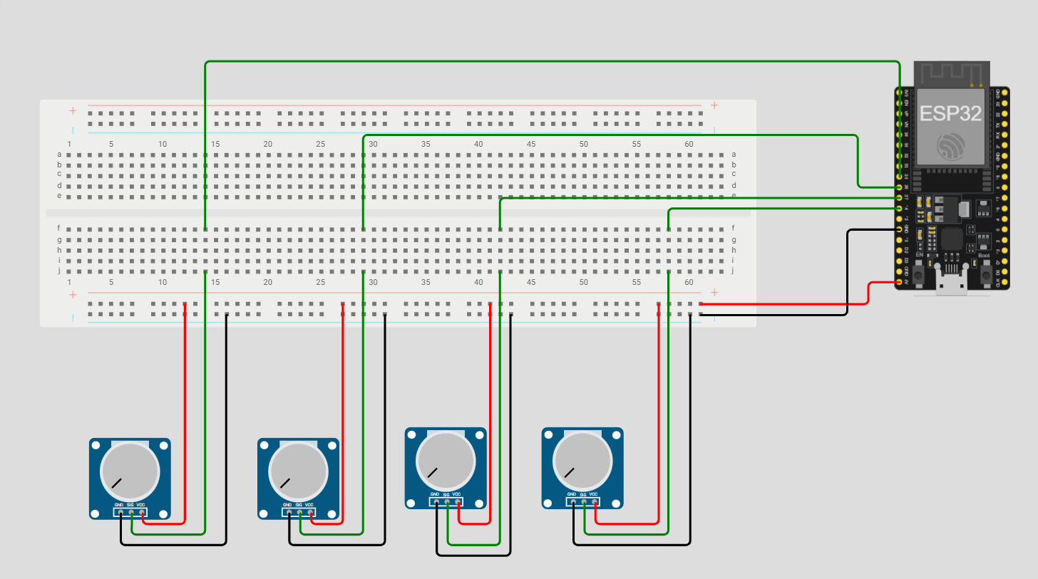
Figure 1: Breadboard wiring diagram — ESP32 with 4 potentiometers

5. Working Principle

5.1 Reading Cell Voltages
Each potentiometer's wiper output is read using the ESP32's 12-bit ADC (analogRead), producing a raw value between 0 and 4095. This raw value is scaled proportionally against a reference of 4.2V — the standard maximum voltage of a single Li-ion cell — to compute a simulated per-cell voltage.

5.2 Pack-Level Calculations
- Pack Voltage: sum of all four cell voltages.
- Average Cell Voltage: pack voltage divided by 4.
- Weakest / Strongest Cell: determined by comparing all four cell voltages.
- Imbalance (%): the percentage difference between the strongest and weakest cell relative to the average cell voltage.

5.3 Battery Health Diagnosis
The system classifies overall battery health using the following logic:
- PACK FAILURE — if the weakest cell voltage drops below 2.8V.
- CRITICAL IMBALANCE — if imbalance is 10% or greater.
- MINOR IMBALANCE — if imbalance is between 5% and 10%.
- HEALTHY — if imbalance is below 5% and no cell has failed.

5.4 Reporting
Once every second, the ESP32 prints a formatted diagnostic report to the serial monitor, listing each cell's voltage, the pack voltage, average voltage, weakest and strongest cells, imbalance percentage, and overall battery health status.

6. Source Code (Arduino / ESP32)
The complete firmware, written in the Arduino IDE for the ESP32 platform, is listed below.
/*
Adaptive Multi-Cell Battery Intelligence Engine
ESP32 + 4 Potentiometers
*/

const int cellPins[4] = {32, 33, 34, 35};

float cellVoltage[4];

float packVoltage;
float averageVoltage;

int weakestCell;
int strongestCell;

float weakestVoltage;
float strongestVoltage;

float imbalance;

String batteryHealth;

const float MAX_CELL_VOLTAGE = 4.2;

void readCells()
{
for (int i = 0; i < 4; i++)
{
int adc = analogRead(cellPins[i]);

cellVoltage[i] = ((float)adc / 4095.0) * MAX_CELL_VOLTAGE;
}
}

void calculatePack()
{
packVoltage = 0;

weakestVoltage = cellVoltage[0];
strongestVoltage = cellVoltage[0];

weakestCell = 0;
strongestCell = 0;

for (int i = 0; i < 4; i++)
{
packVoltage += cellVoltage[i];

if (cellVoltage[i] < weakestVoltage)
{
weakestVoltage = cellVoltage[i];
weakestCell = i;
}

if (cellVoltage[i] > strongestVoltage)
{
strongestVoltage = cellVoltage[i];
strongestCell = i;
}
}

averageVoltage = packVoltage / 4.0;

imbalance =
((strongestVoltage - weakestVoltage) / averageVoltage) * 100.0;
}

void batteryDiagnosis()
{
if (weakestVoltage < 2.8)
{
batteryHealth = "PACK FAILURE";
}
else if (imbalance >= 10)
{
batteryHealth = "CRITICAL IMBALANCE";
}
else if (imbalance >= 5)
{
batteryHealth = "MINOR IMBALANCE";
}
else
{
batteryHealth = "HEALTHY";
}
}

void displayReport()
{
Serial.println("--------------------------------------");

for (int i = 0; i < 4; i++)
{
Serial.print("Cell ");
Serial.print(i + 1);
Serial.print(": ");
Serial.print(cellVoltage[i], 2);
Serial.println(" V");
}

Serial.println();

Serial.print("Pack Voltage : ");
Serial.print(packVoltage, 2);
Serial.println(" V");

Serial.print("Average Cell : ");
Serial.print(averageVoltage, 2);
Serial.println(" V");

Serial.print("Weakest Cell : ");
Serial.print(weakestCell + 1);
Serial.print(" (");
Serial.print(weakestVoltage, 2);
Serial.println(" V)");

Serial.print("Strongest Cell : ");
Serial.print(strongestCell + 1);
Serial.print(" (");
Serial.print(strongestVoltage, 2);
Serial.println(" V)");

Serial.print("Imbalance : ");
Serial.print(imbalance, 2);
Serial.println(" %");

Serial.print("Battery Health : ");
Serial.println(batteryHealth);

Serial.println("--------------------------------------");
}

void setup()
{
Serial.begin(115200);

analogReadResolution(12);

for (int i = 0; i < 4; i++)
{
pinMode(cellPins[i], INPUT);
}
}

void loop()
{
readCells();

calculatePack();

batteryDiagnosis();

displayReport();

delay(1000);
}

7. Results and Observations
Rotating each potentiometer changes its corresponding simulated cell voltage in real time. The serial monitor accurately reflects these changes, correctly recalculating pack voltage, average voltage, and imbalance percentage on every loop iteration. Deliberately setting one potentiometer far below the others correctly triggers the CRITICAL IMBALANCE or PACK FAILURE diagnosis, confirming that the detection logic behaves as intended.
This confirms the system is ready to be adapted for real battery packs, provided each cell voltage is first scaled down to the ESP32's safe ADC input range (0–3.3V) using an appropriate resistor voltage-divider network, and proper electrical isolation is used for safety.

8. Applications
- Battery Management Systems (BMS) for electric vehicles and e-bikes.
- Solar power storage systems using multi-cell Li-ion / LiFePO4 packs.
- Portable power banks and UPS systems requiring cell-level monitoring.
- Educational demonstration of battery balancing and diagnostic concepts.

9. Future Scope
- Replace potentiometers with real cell voltage-divider circuits for live battery monitoring.
- Add active cell balancing circuitry (MOSFET-based bypass balancing).
- Integrate a display (OLED/TFT) for standalone visual diagnostics.
- Add Wi-Fi/Bluetooth (leveraging ESP32's built-in connectivity) for remote monitoring and mobile app integration.
- Log historical data to an SD card or cloud database for long-term battery health trend analysis.

10. Conclusion
The Adaptive Multi-Cell Battery Intelligence Engine successfully demonstrates the core principles of multi-cell battery monitoring and diagnostics using an ESP32 microcontroller. By simulating cell voltages with potentiometers, the project validates the underlying algorithms for pack voltage calculation, imbalance detection, and health classification — forming a solid foundation for a full-scale, real-world Battery Management System.

